NEXT JS




Next.js

The Next.js Logo
Original author(s) | Guillermo Rauch^{[1]}
Developer(s) | Vercel and the open-source community^{[2]}
Initial release | October 25, 2016; 8 years ago^{[3]}
Stable release | 15.0.3^{[4]} / 7 November 2024; 26 days ago
Preview release | v15.0.4-canary.22 ^{[5]}
Repository | - github.com/vercel/next.js
Written in | JavaScript, TypeScript, and Rust
Platform | Web platform
Size | 17.0 MB
Type | Web application framework
License | MIT License
Website | nextjs.org

-Next.js is an open-source web development framework created by the private company Vercel providing React-based web applications with server-side rendering and static rendering.
-React documentation mentions Next.js among "Recommended Toolchains" advising it to developers when "building a server-rendered website with Node.js".^{[6]} Where traditional React apps can only render their content in the client-side browser, Next.js extends this functionality to include applications rendered on the server-side.
Background
[edit]
Next.js is a React framework that enables several extra features, including server-side rendering and static rendering.^{[9]} React is a JavaScript library that is traditionally used to build web applications rendered in the client's browser with JavaScript.^{[10]} Developers recognize several problems with this strategy however, such as not catering to users who do not have access to JavaScript or have disabled it, potential security issues, significantly extended page loading times, and harm to the site's overall search engine optimization.^{[10]} Frameworks such as Next.js sidestep these problems by allowing some or all of the website to be rendered on the server-side before being sent to the client.^{[10][11]} Next.js is one of the most popular frameworks for React.^{[12]} It is one of several recommended "toolchains" available when starting a new app, all of which provide a layer of abstraction to aid in common tasks.^{[13]} Next.js requires Node.js and can be initialized using npm.

What is React?
-React.Js is an open-source Javascript library used to create user interface (UI). It was developed by Facebook. It helps create reusable UI components and uses virtual DOM to improve app performance. It can be used with both client and server sides and is easily integrated with other front-end frameworks. Its component-based approach, reusability, developer tools, and performance optimization make it a great choice for developers.

7 Best React.js Frameworks
React.js is a widely used library of JavaScript for frontend development, that uses components to make the UI more interactive and help the developers in making the process more simple. To further optimise the complex part of react, developers have made frameworks that have pre-build function which are commonly used. So, Following are the best react.js Frameworks that each developer should know and implement in their projects:
- 1. React Native
- 2. Next.js
- 3. Storybook
- 4. Material UI
- 5. Gatsby
- 6. Semantic UI React
- 7. React Bootstrap

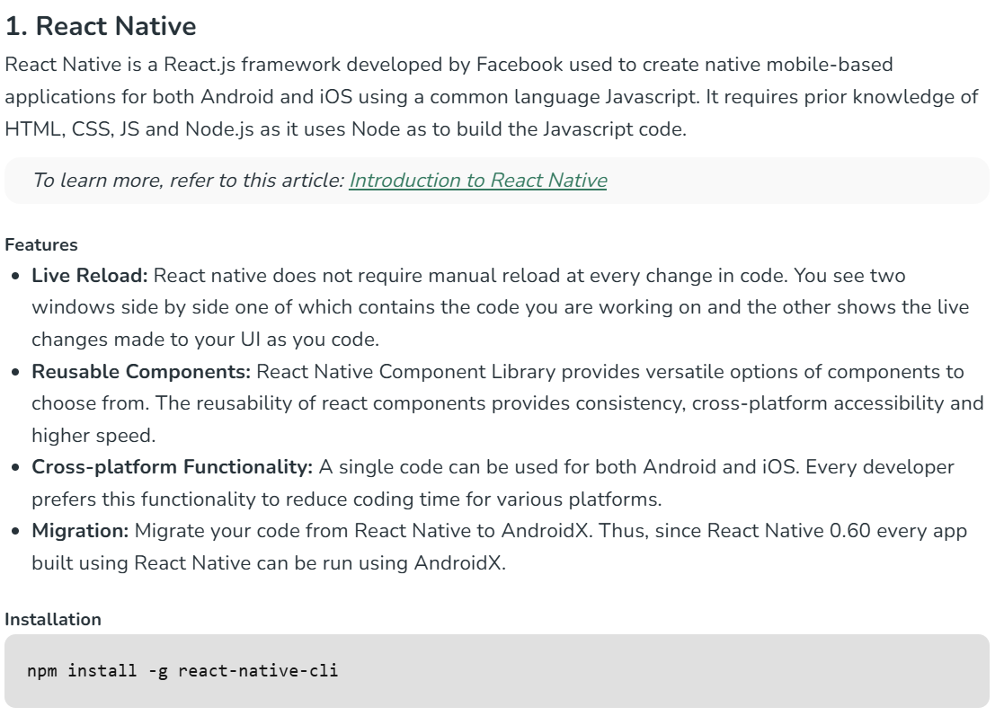
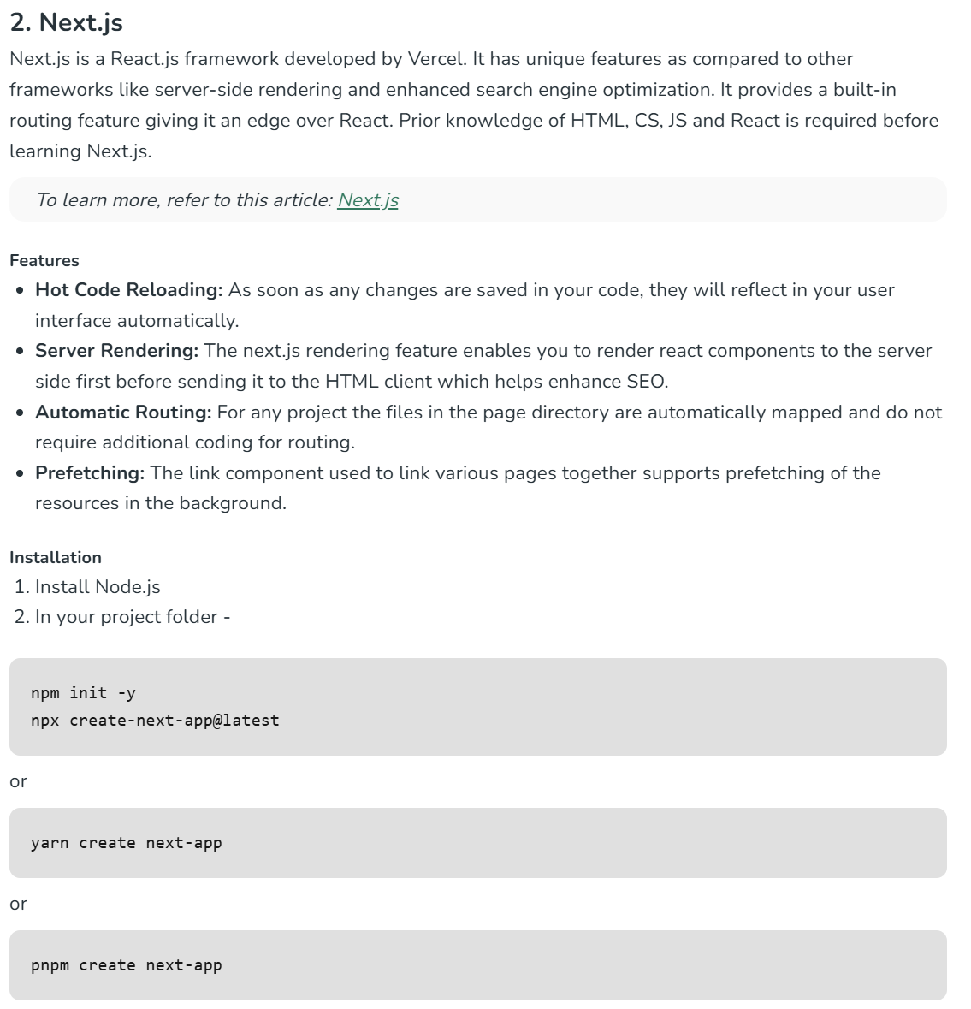
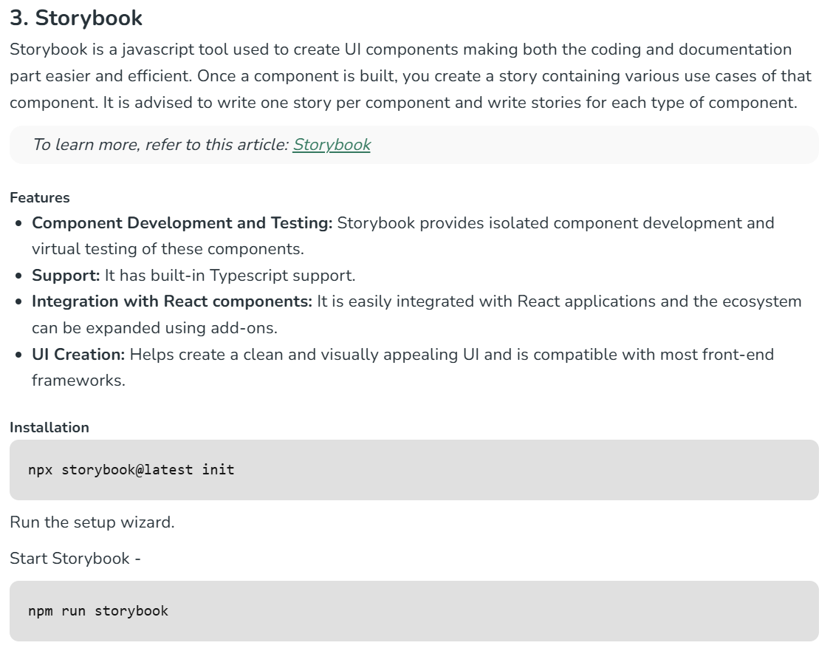
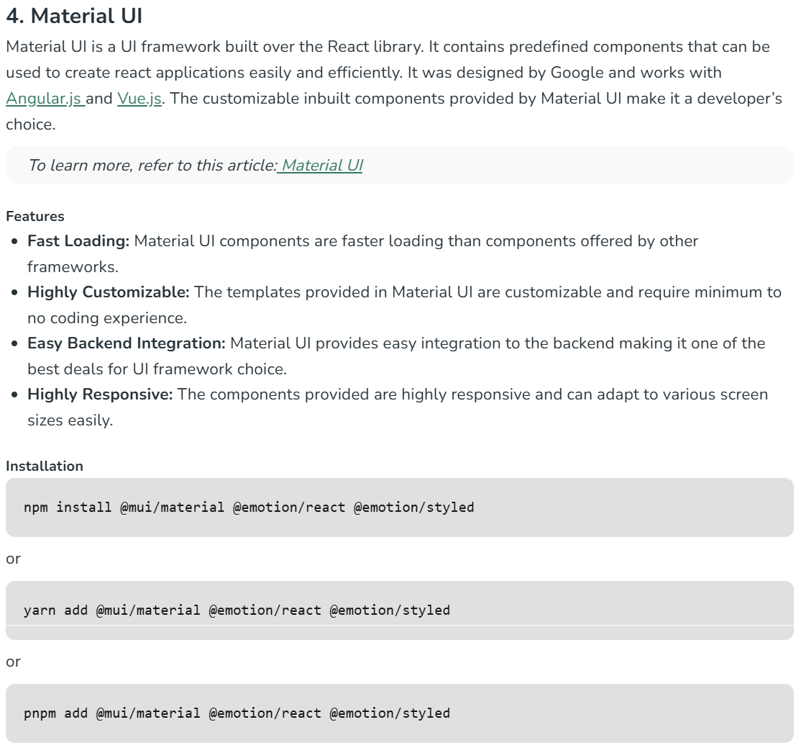

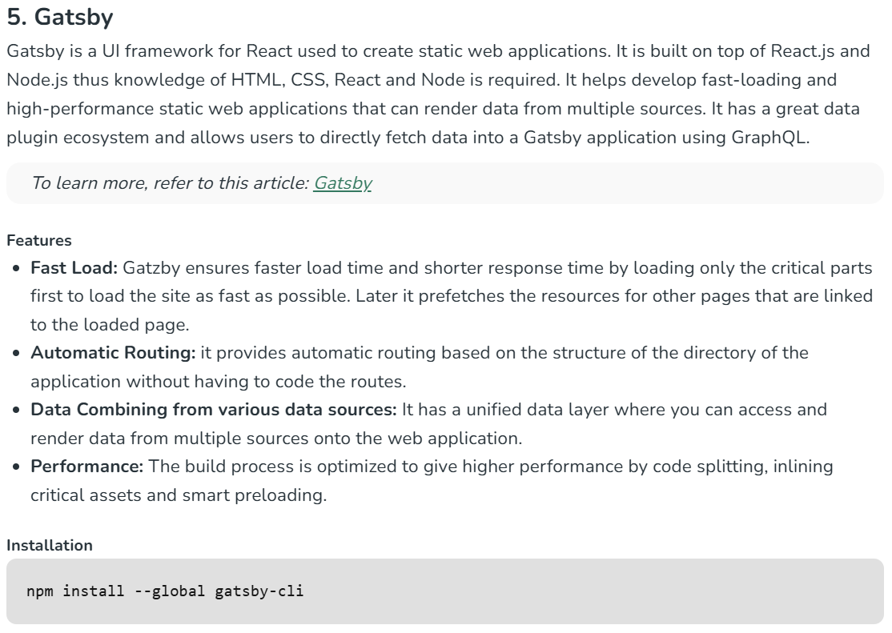
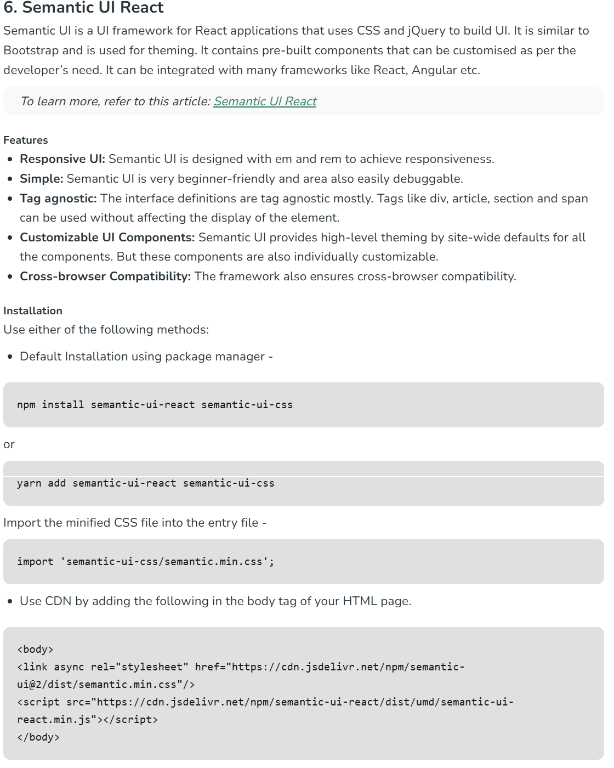
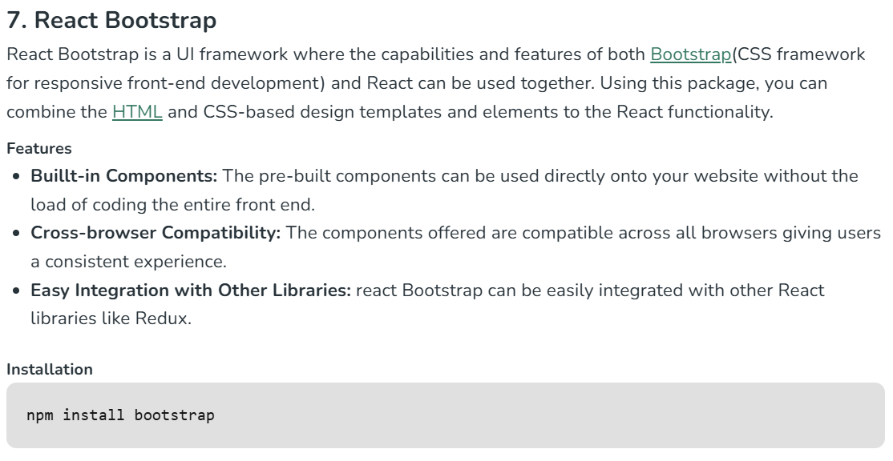

NEXT JS OVERVIEW

-To begin with Next.js you can start with the following topics. This tutorial will help you to learn Next.js on your own pace and to get best out of this we recommend you to do coding practice with each lessons.
Next.js Basics
Before diving deep into any tutorial, always prepare yourself from basics.
- Next.js Overview
- Next.js Environment Setup
- Next.js Rendering
Next.js Styling
Next.js support inbuild css-in-js library named styled-jsx.
- Next.js CSS
- Next.js Global CSS
Next.js Routing
Next.js creates website links automatically based on how you organize your files. If you add a new file in the pages folder, it will be a new page on your website.
- Next.js Routing
- Next.js Pages
- Next.js Imperative Routing
- Next.js Shallow Routing
Next.js API Routes
API Routes is a way to create rest API using Next.js. It can maps any file present in /pages/api folder and will be treated as API end point.
- Next.js API Routes
- Next.js API MiddleWares

NEXT JS HISTORY

-Next.js was create by Vercel(formerly ZEIT) in 2016 to bridge the gap in ReactJS ecosystem. From 2016 to till now Next.js improved a lot as well. the current stable Next.js version is 15.0.3 (7th November 2024).
Next.js Versions
Year | Version | Key Features
2016 | Next.js 1.0.0 (October) | Initial release
2017 | Next.js 2.0.0 | Added automatic code splitting
2017 | Next.js 3.0.0 | Introduced dynamic imports
2017 | Next.js 4.0.0 | Added zero-configuration TypeScript support
2018 | Next.js 5.0.0 | Added webpack 4 support
2018 | Next.js 6.0.0 | Improved error handling
2018 | Next.js 7.0.0 | Added Webpack 4 optimization features
2019 | Next.js 8.0.0 | Introduced serverless mode
2019 | Next.js 9.0.0 | Added built-in zero-config TypeScript support, automatic static optimization
2020 | Next.js 9.3 | Introduced getStaticProps and getStaticPaths
2020 | Next.js 10.0.0 | Added built-in Image Component, Automatic Image Optimization
2021 | Next.js 11.0.0 | Introduced Webpack 5 support, Script optimization
2021 | Next.js 12.0.0 | Added Rust compiler, middleware, React 18 support
2022 | Next.js 12.1.0 | On-demand ISR (Incremental Static Regeneration)
2022 | Next.js 12.2.0 | Improved middleware features
2022 | Next.js 13.0.0 | Introduced app directory, Turbopack (alpha), new Image component
2023 | Next.js 13.4 | App Router stable release
2023 | Next.js 14.0.0 | Improved server actions, Partial prerendering
2023 | Next.js 15.0.3 | React 19 support, and a stable release for Turbopack in development.

WHAT IS NEXT JS

-Next.js is React based framework with server side rendering capability to create full stack web apps. To create user interface you can use React but Next.js is for additional features and customizations.
-Next.js is an open-source web development framework based on React and has gained popularity due to its amazing features. It is developed by Vercel and Next.js stands out for its capabilities, including server-side rendering(SSR) and enhanced search engine optimization (SEO). Next.js provides built-in routing, making it simple to create dynamic routes and handle navigation within your application.
-Particularly for server-side rendering and static site generation, making it an excellent choice for creating highly optimized and dynamic websites.
Key Features of Next.js:
- Server-Side Rendering (SSR):
  - Renders pages on the server before sending them to the client, improving performance and SEO.
- Static Site Generation (SSG):
  - Generates HTML at build time for better speed and SEO for static pages.
- API Routes:
  - Allows you to create serverless API endpoints within your application.
- Automatic Code Splitting:
  - Loads only the JavaScript required for the current page, reducing page load time.
- Routing:
  - Built-in file-based routing system—no need to configure routes manually.
- CSS and Styling:
  - Supports various styling options such as CSS modules, global CSS, Sass, and styled-components.
- Image Optimization:
  - Optimizes images out of the box with features like lazy loading and automatic resizing.
- Internationalization (i18n):
  - Built-in support for creating multilingual applications.
- TypeScript Support:
  - Seamless integration with TypeScript for type-safe development.
- Incremental Static Regeneration (ISR):
  - Updates static content without needing a full rebuild, keeping your site fast and up-to-date.
Why Use Next.js?
- Improved SEO: Thanks to SSR and SSG.
- Enhanced Performance: Features like image optimization and code splitting.
- Developer Experience: Simple API and a rich ecosystem of tools.
- Flexibility: Works well for both static sites and dynamic applications.
It is commonly used for:
- E-commerce websites
- Blogs and content-heavy sites
- Dashboards and web applications
- Portfolio sites

WHY NEXT JS

-By using Next.js, you can create robust react based application quite easily and test them. Next.js is created by Vercel, which is a cloud based platform to help the developer to develop application, deploy and scale-up the applications as well.
-Next.js is capable of configuring tools needed in React applications, so you can be more productive and focus on development rather the configurations. Next.js solved the common application requirements like routing, data fetching, caching and improve the development experience.
-Next.js was invented to reduce the load on web browsers and provide enhanced security. There are some other features as listed below.
Feature | Description
Routing | Next.js uses file system based router. Whenever we add any page to pages directory, it is automatically available via url.
Rendering | Next.js rendering supports on both side rendering(client and server side) user's browser and the server. So this makes faster by pre-building some pages and creating others as per requirements.
Data Fetching | Server Components can now fetch data more easily using async/await, and have better ways to save, cache, and update data using an improved fetch API.
Styling | Next.js support inbuild css-in-js library named styled-jsx. It allows to write CSS within a React component and these styles will be scoped to component.
Optimizations | Optimizing images, fonts, scripts will help your app to perform better and improve the SEO of your web applications.
TypeScript | Next.js support TypeScript, so there is better type checking and more efficient compilation compared to JavaScript.

-Next.js is a React framework that extends React’s capabilities to build server-rendered and statically generated web applications. Here are some of its key features:
- Server-side Rendering (SSR): This improves SEO and initial load performance by rendering pages on the server. Content is already available for search engines to index, and users see a fully rendered page on the first load.
- Static Site Generation (SSG): This pre-renders pages at build time, making them super fast to load. Ideal for content that changes infrequently, like blog posts or landing pages.
- Automatic Code Splitting: This breaks down your application code into smaller bundles, improving load times by only loading the code needed for the current page.
- Data Fetching: Next.js offers several ways to fetch data, including getStaticProps for fetching data at build time and getServerSideProps for fetching data on each request. This flexibility allows you to choose the most appropriate method for your specific needs.
- Routing: Routing is simplified in Next.js. It automatically creates routes based on the file structure of your pages directory, making it easy to manage your application’s URL structure.
- Image Optimization: Next.js automatically optimizes images, including resizing and compressing them, for faster loading times and improved SEO.
- Built-in CSS and JavaScript Bundling: Next.js takes care of bundling and optimizing your CSS and JavaScript code, streamlining the development process.
- API Routes: Next.js allows you to create serverless functions directly within your application using API routes. This lets you add backend functionality to your React application without needing a separate server.

Next.js vs React

Feature | Next.js | React
Type | Framework | Library
Learning curve | Steeper (due to additional features) | Easier
Flexibility | Less flexible (opinionated) | More flexible
Code complexity | Less code needed (built-in features) | More code needed (external libraries)
Rendering | Server-side rendering (SSR) optional | Client-side rendering (CSR) by default
SEO | Better SEO due to pre-rendered content | Can be achieved with additional libraries
Application | E-commerce, marketing websites, blogs | Complex web applications, social media, dashboard

NEXT JS Frequently Questions

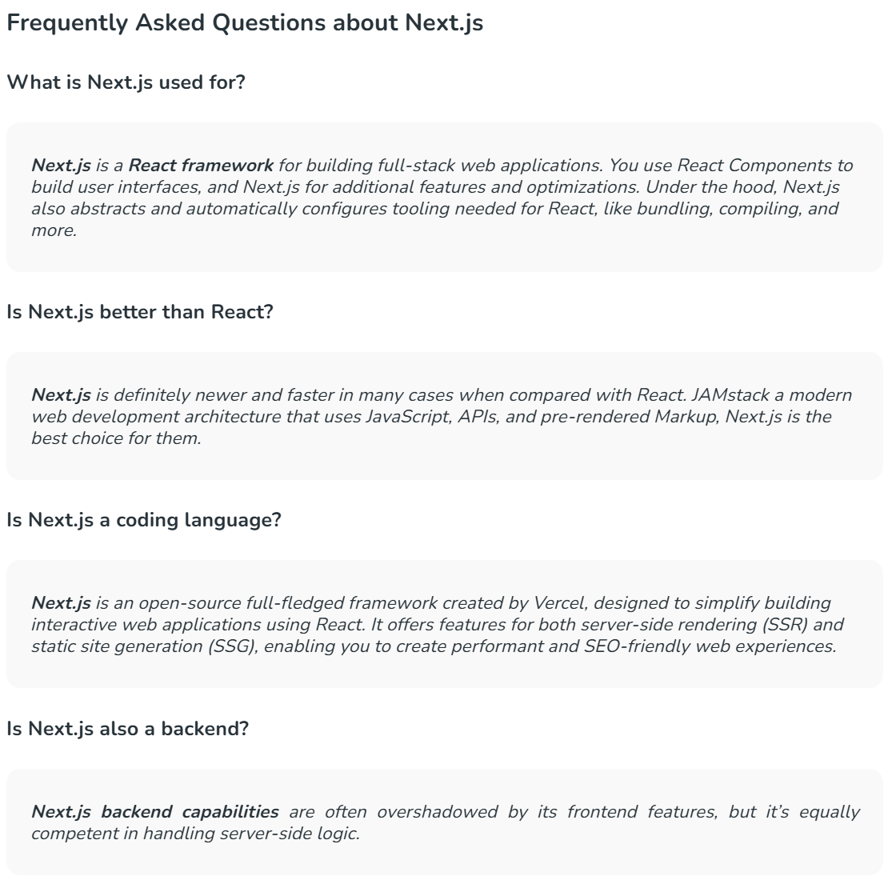
There are some very Frequently Asked Questions(FAQ) about Next.js
QNO1:-What is NextJS used for?
Next.js is a React framework for building full-stack web applications.
QNO2:-Is NextJS better than React?
Next. js is more opinionated than react but less flexible than React. Use Next.js for configuring tools needed in React applications.
QNO3:-Is NextJS frontend or backend?
It can be used for both but recommended to use as a frontend.
QNO4:-Is NextJS the same as Nodejs?
No, both are different - Next.js is React based framework and Node.js JavaScript runtime environment.

NEXT JS ADVANTAGES
Advantages of Next.js over ReactJS
- Hot Code Reload Next.js server detects modified files and reloads them automatically.
- Automatic Routing: No need to configure any url for routing. files are to be placed in pages folder. All urls will be mapped to file system. Customization can be done.
- Component specific styles: The styled-jsx provides support for global as well as component specific styles.
- Server side rendering: React components are pre-rendered on server hence loads faster on client.
- Node Ecosystem: Next.js being react based gels well with Node ecosystem.
- Automatic code split: Next.js renders pages with libraries they need. Next.js instead of creating a single large JavaScript file, creates multiples resources. When a page is loaded, only required JavaScript page is loaded with it.
- Prefetch: Next.js provides Link component which is used to link multiple components supports a prefetch property to prefetch page resources in background.
- Dynamic Components: Next.js allows to import JavaScript modules and React Components dynamically.
- Export Static Site: Next.js allows to export full static site from your web application.
- Built-in Typescript Support: Next.js is written in Typescripts and provides excellent Typescript support.

NEXT JS OVERVIEW

How Does Next.js Work?
-Next.js supports both Server-Side-Rendering and Client-Side-Rendering. So you can decide which one is required in your application. Depending on the situation it helps with SEO and quick access to your application.
-Please check the below diagram to get the idea of - "How Next.js works under the hood?" We will explain all these steps in this tutorial.
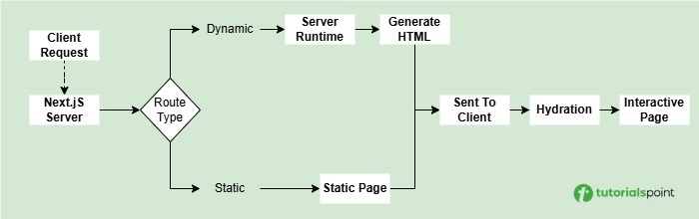

NEXT JS INSTALLATION

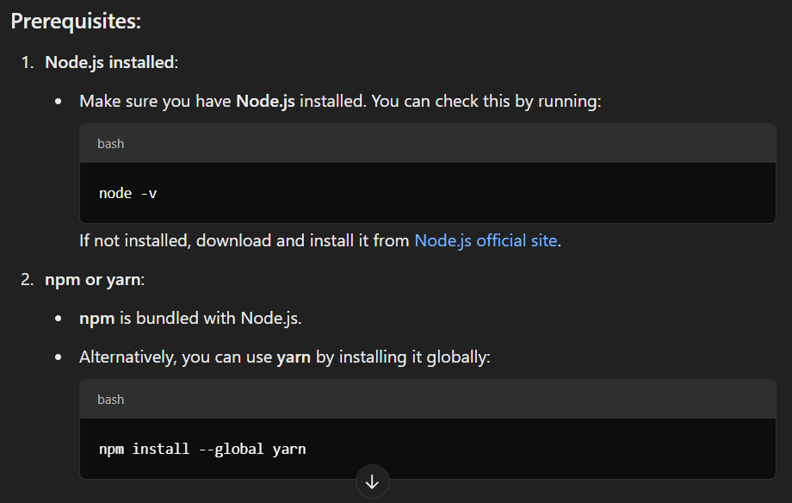
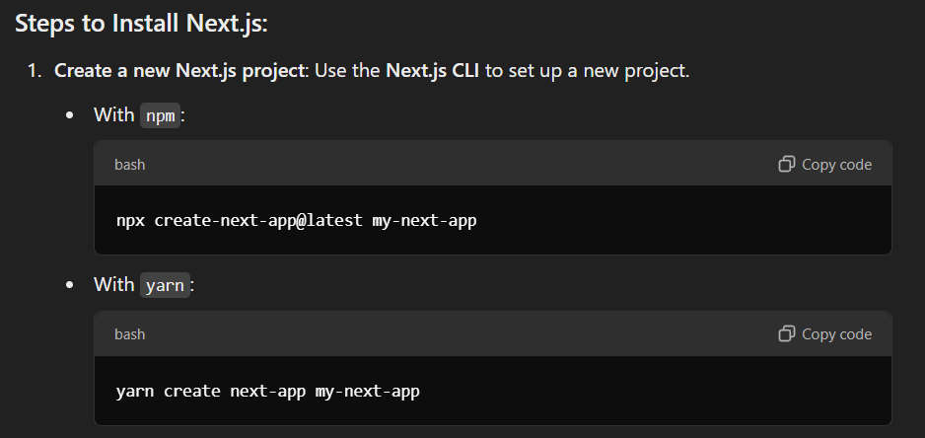

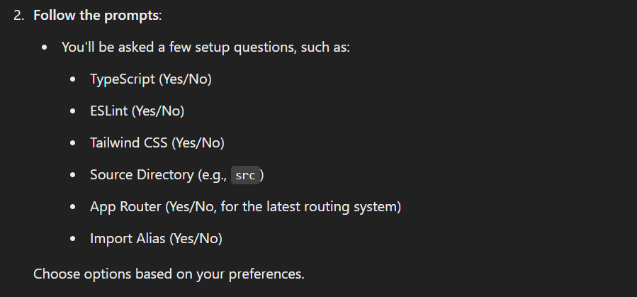

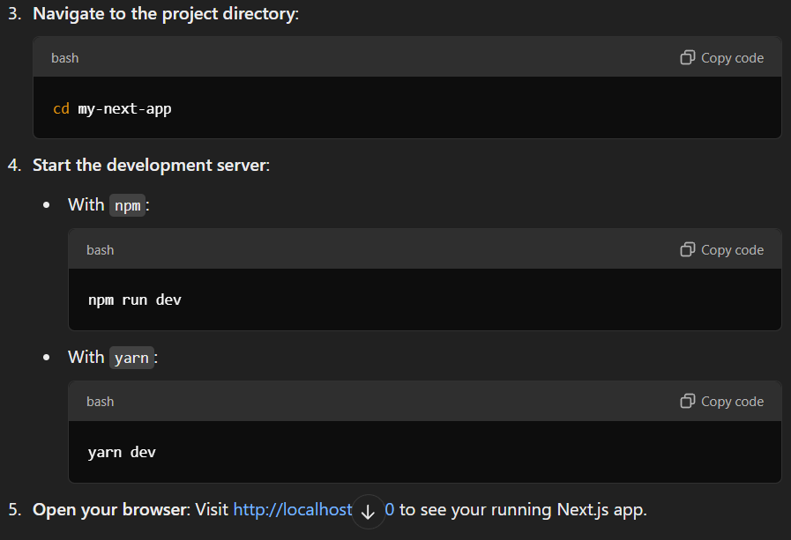

OR

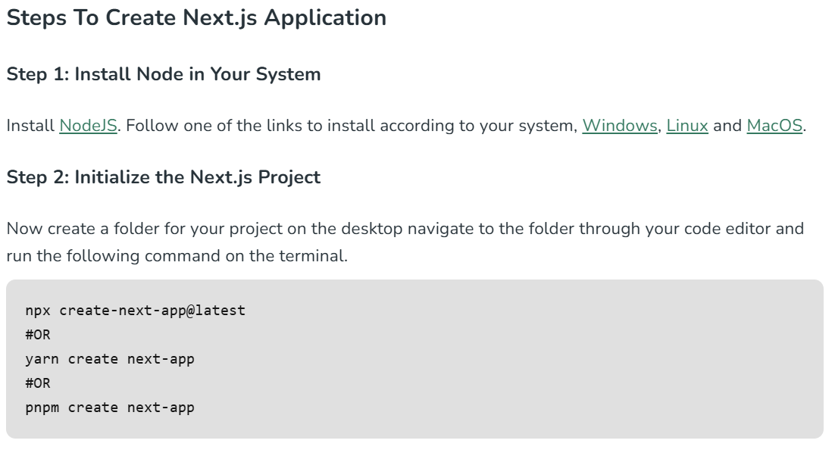
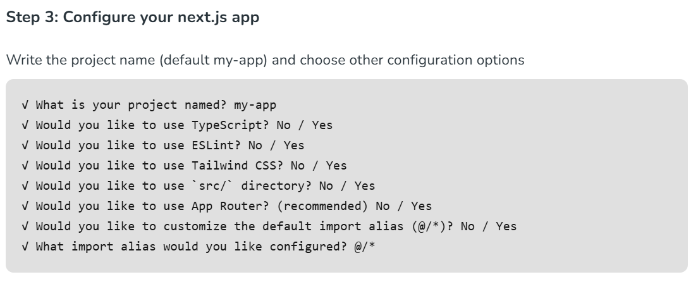
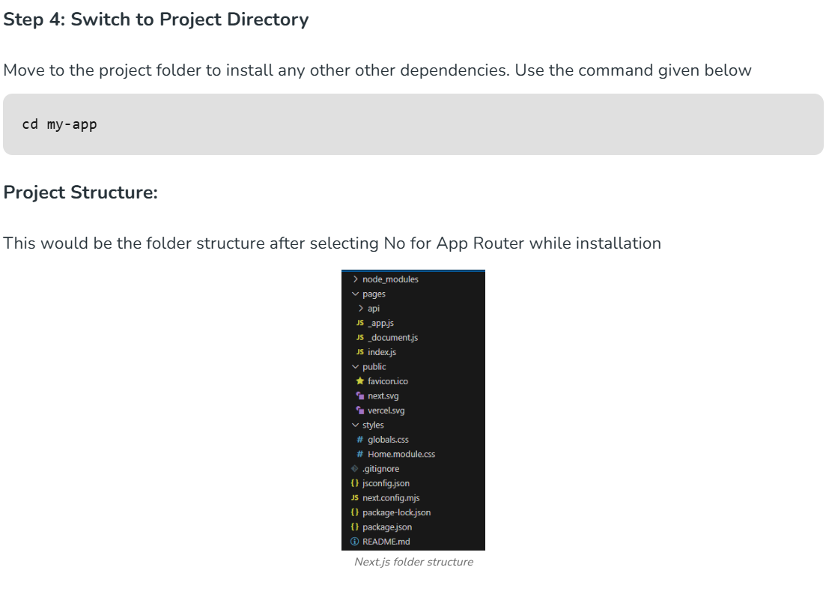

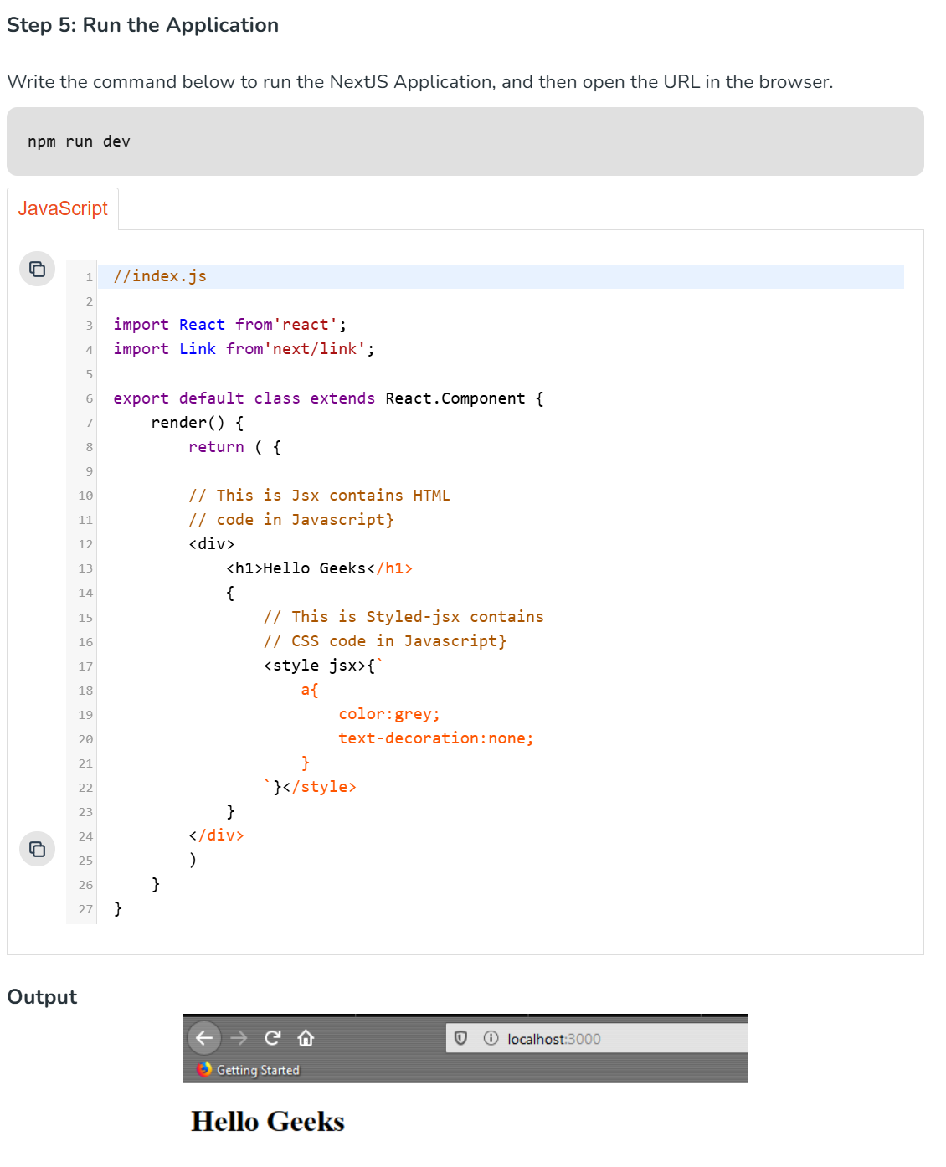

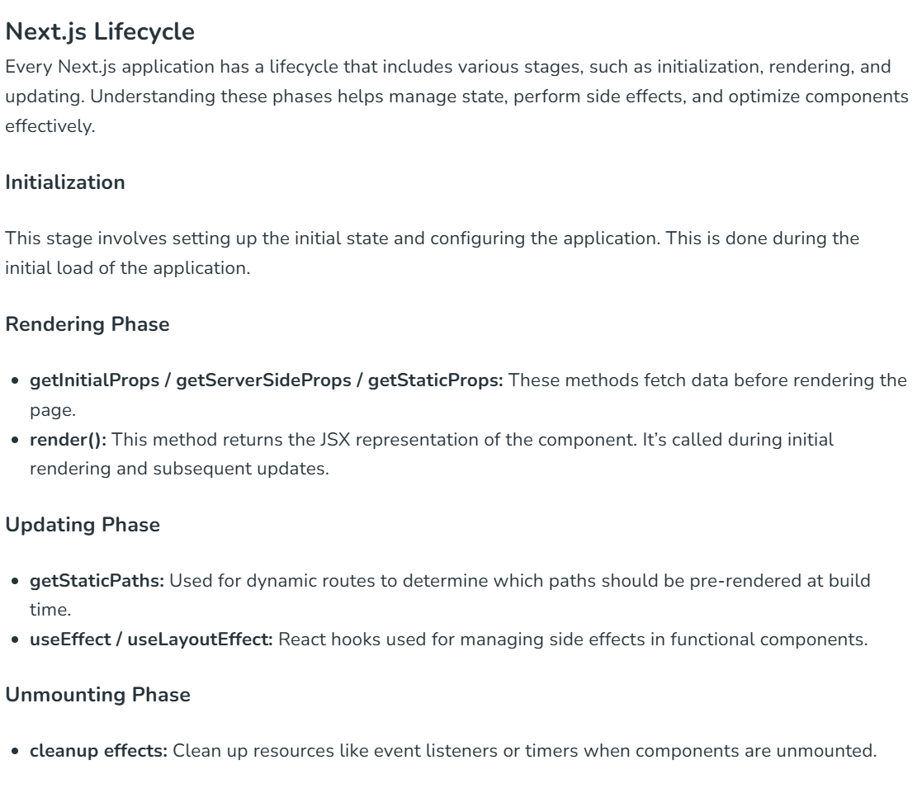

OR

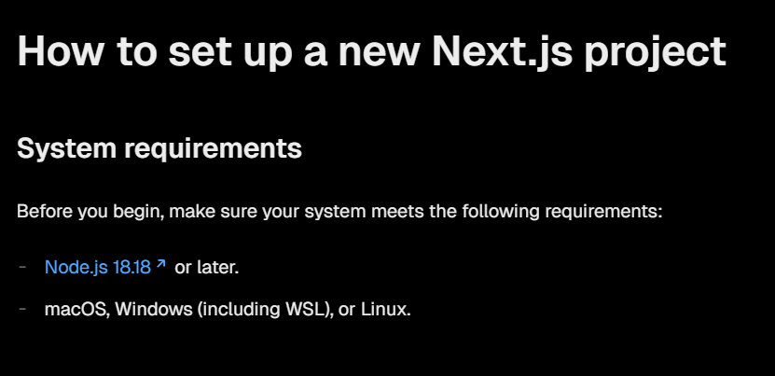
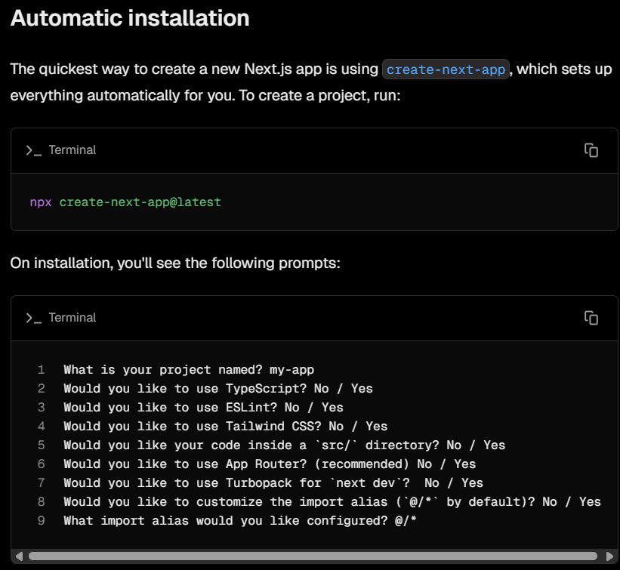

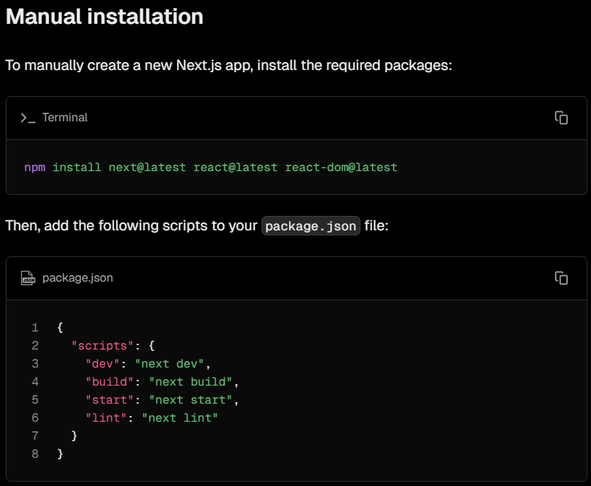
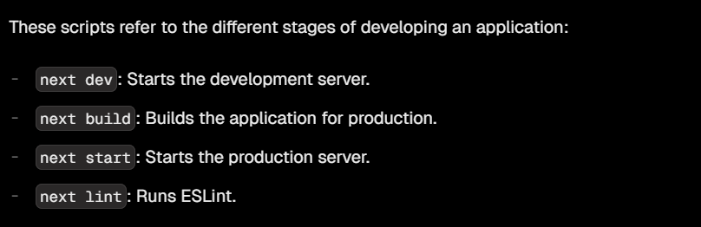

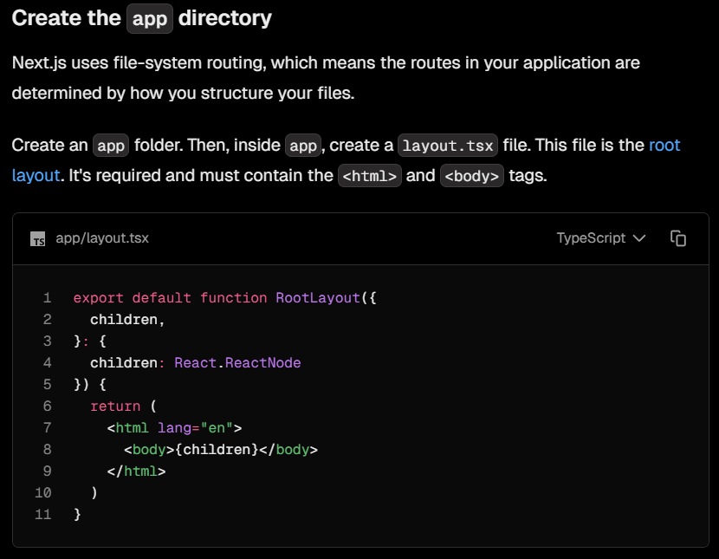
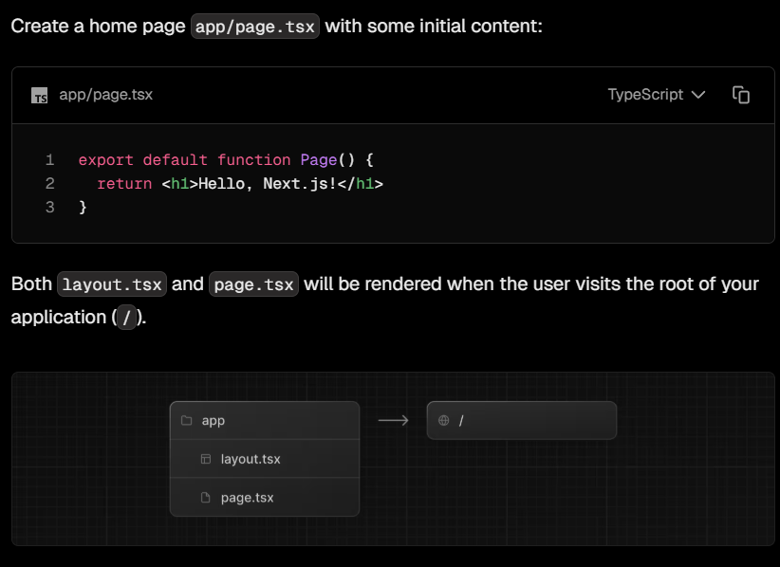

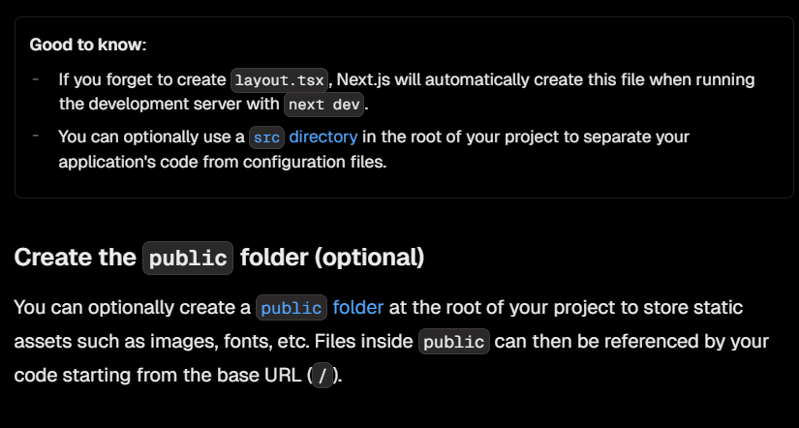
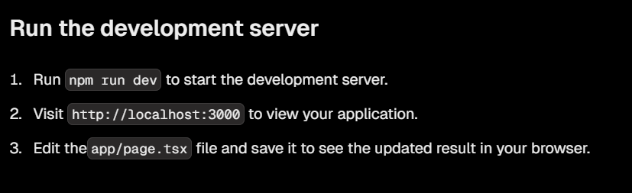

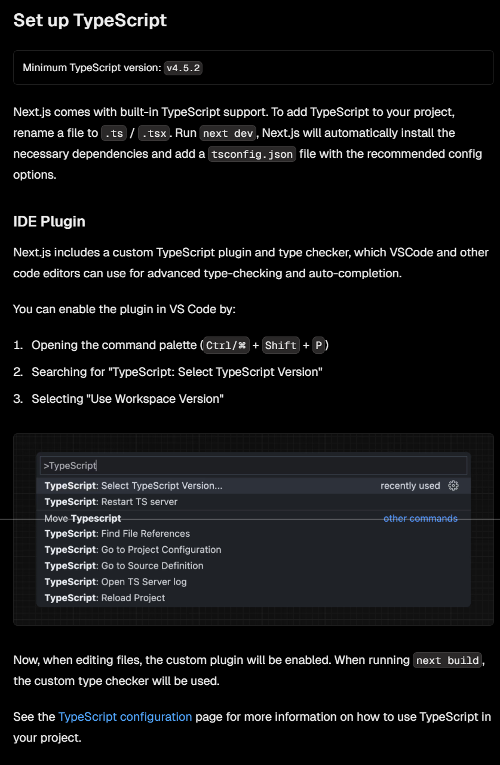
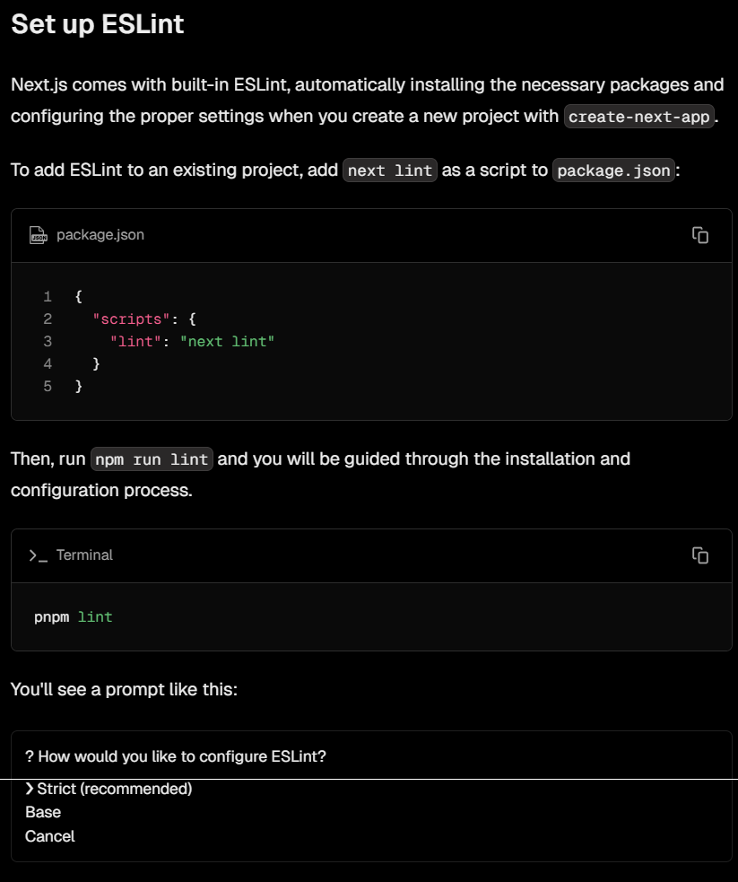
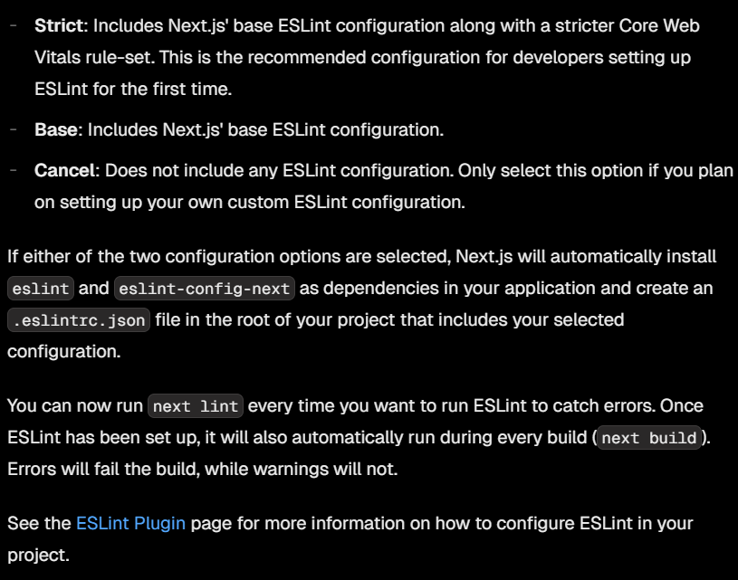
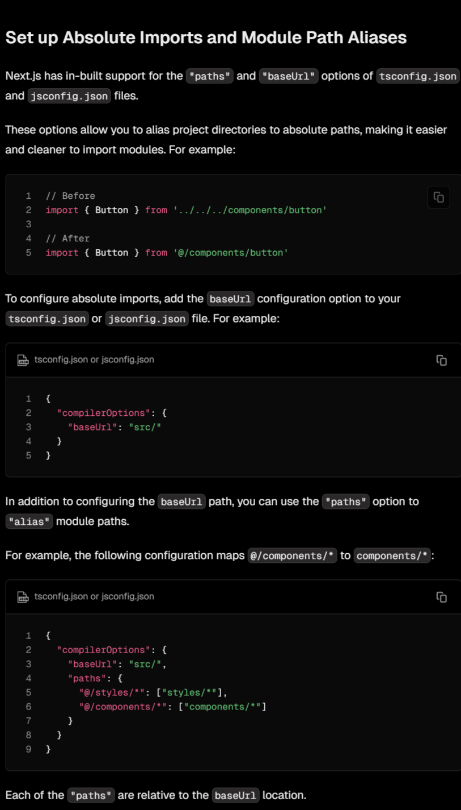

NEXT JS COMMANDS
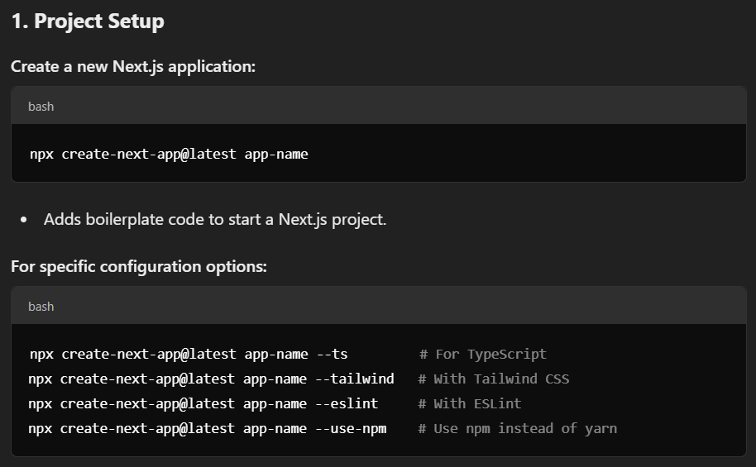
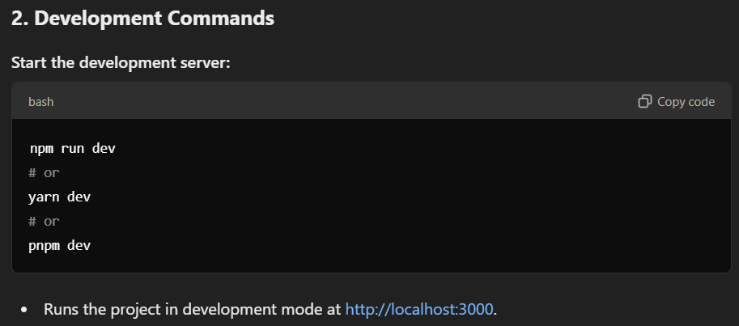

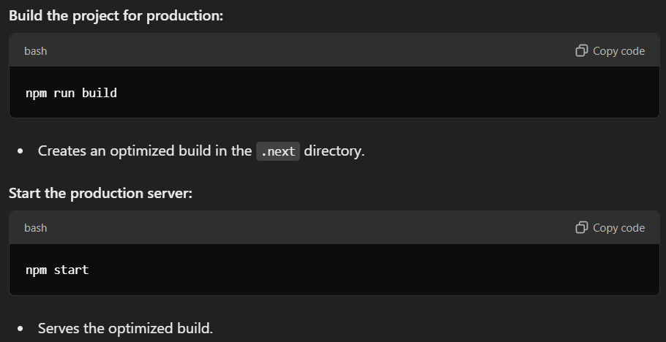
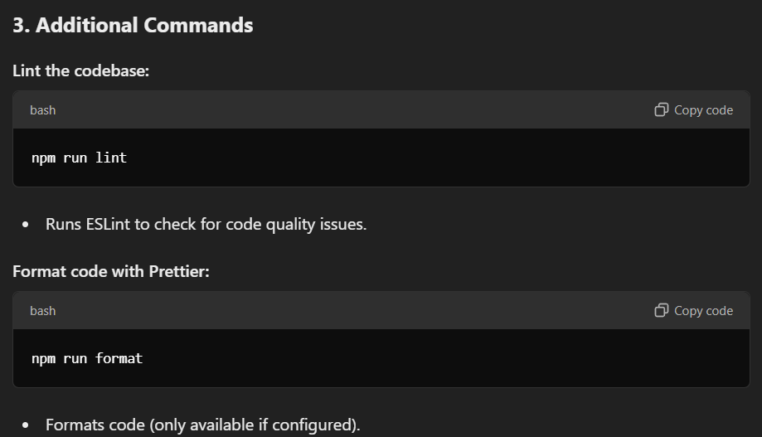

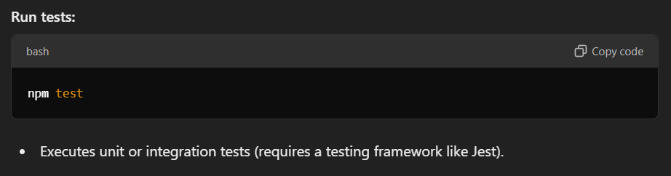

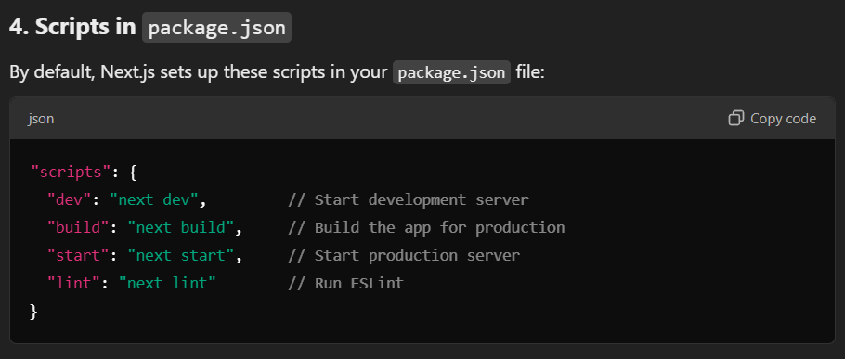
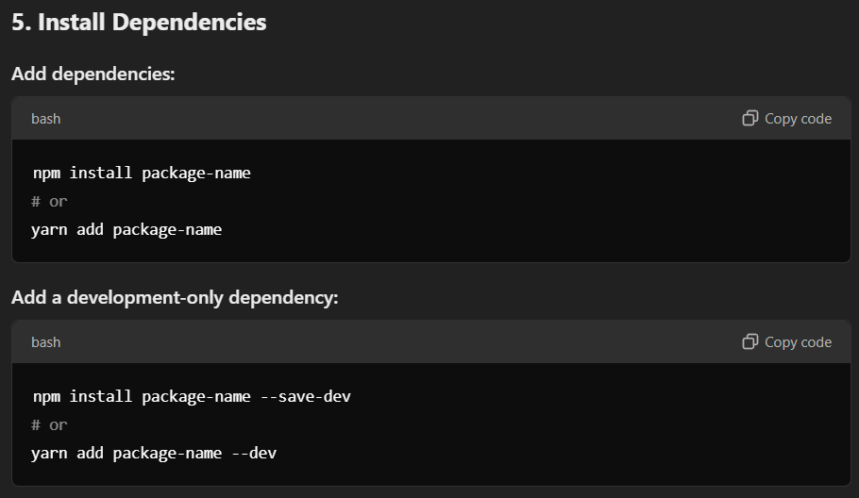
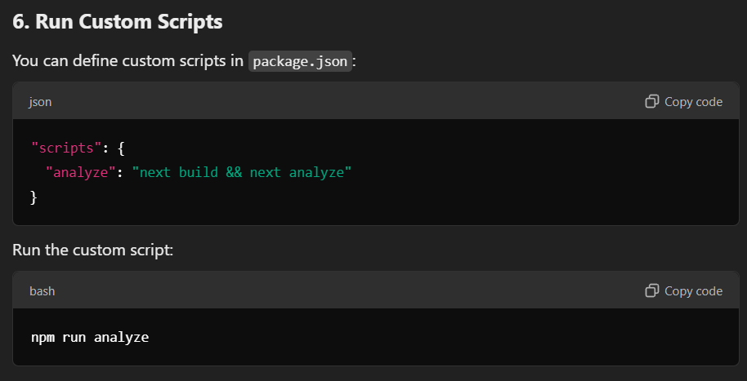
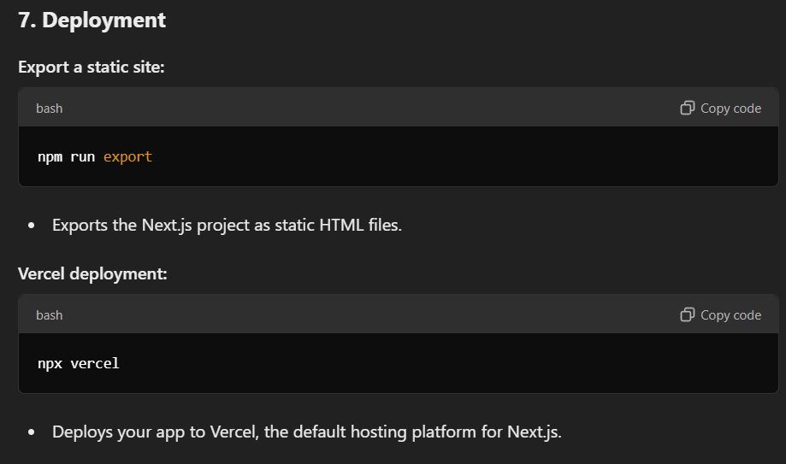

NEXT JS ROUTING

-Next.js uses file system based router. Whenever we add any page to pages directory, it is automatically available via url. Following are the rules of this router.

IMPORTANAT NOTES

DIRECTLY OPEN NEXTJS

